## B’nei mitzvah word search

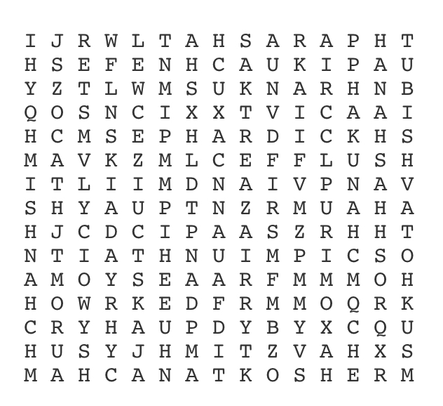

|  |  |
| --- | --- |
| ASHKENAZI  CHANUKAH  COMMANDMENTS  HALACHA  IDENTITY  JUDAISM  KOSHER  MISHNAH  MITZVAH  MIZRACHI  PARASHAT | PESACH  PIKUACH NEFESH  PURIM  ROSH HASHANAH  SEPHARDIC  SUKHOT  TALMUD  TANACH  TORAH  TUBISHVAT  YOM KIPPUR |